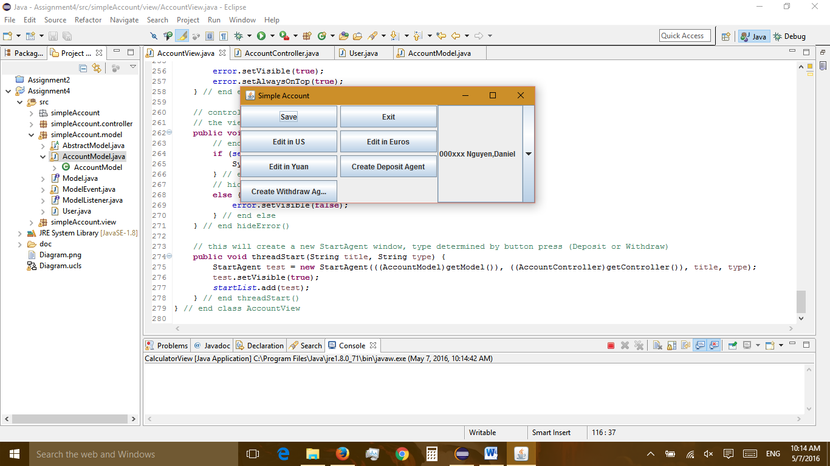

Figure : Start Screen

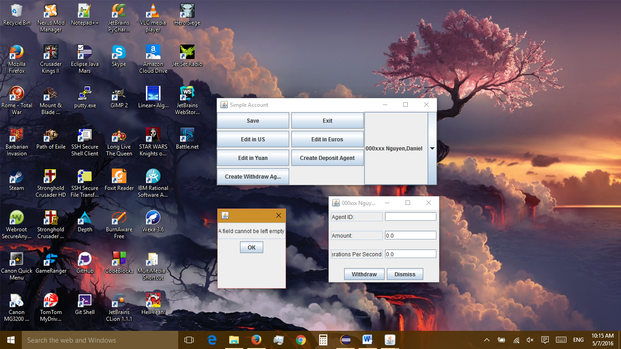

Figure : Empty fields left in StartAgent window

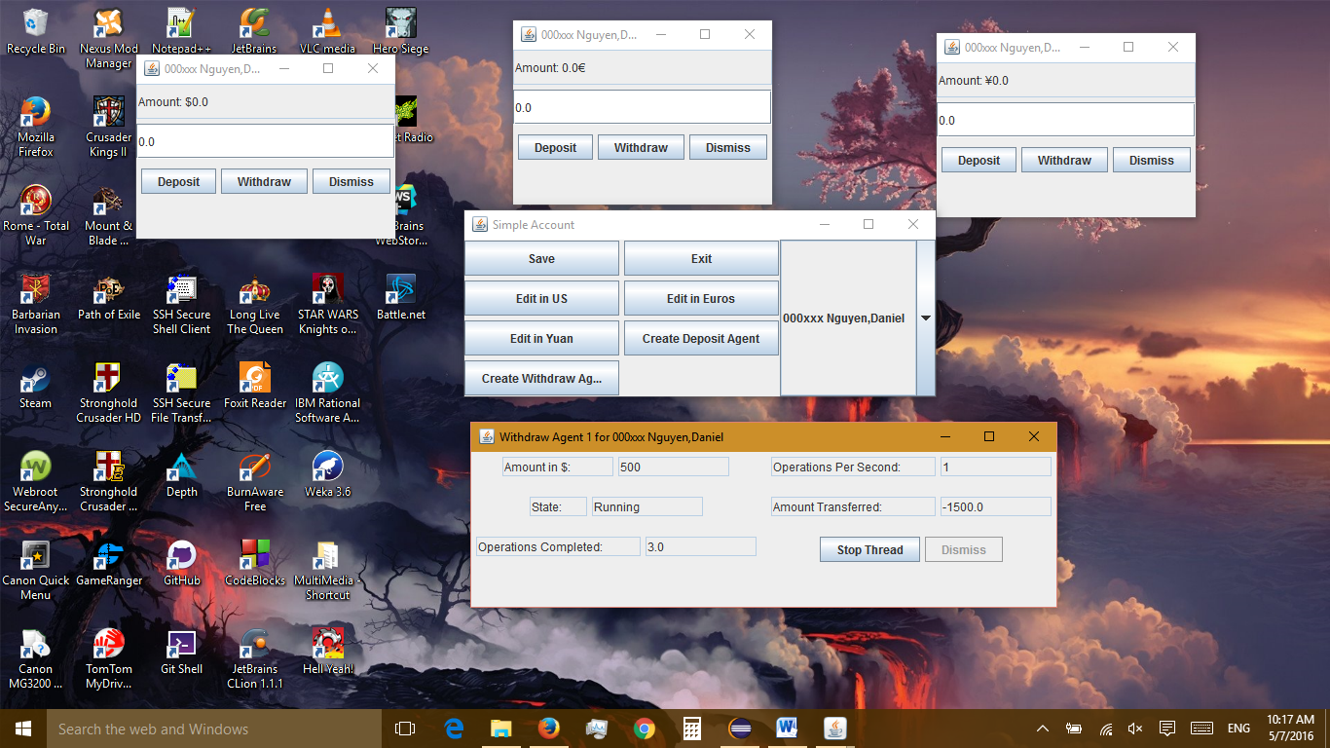

Figure : Withdraw window running

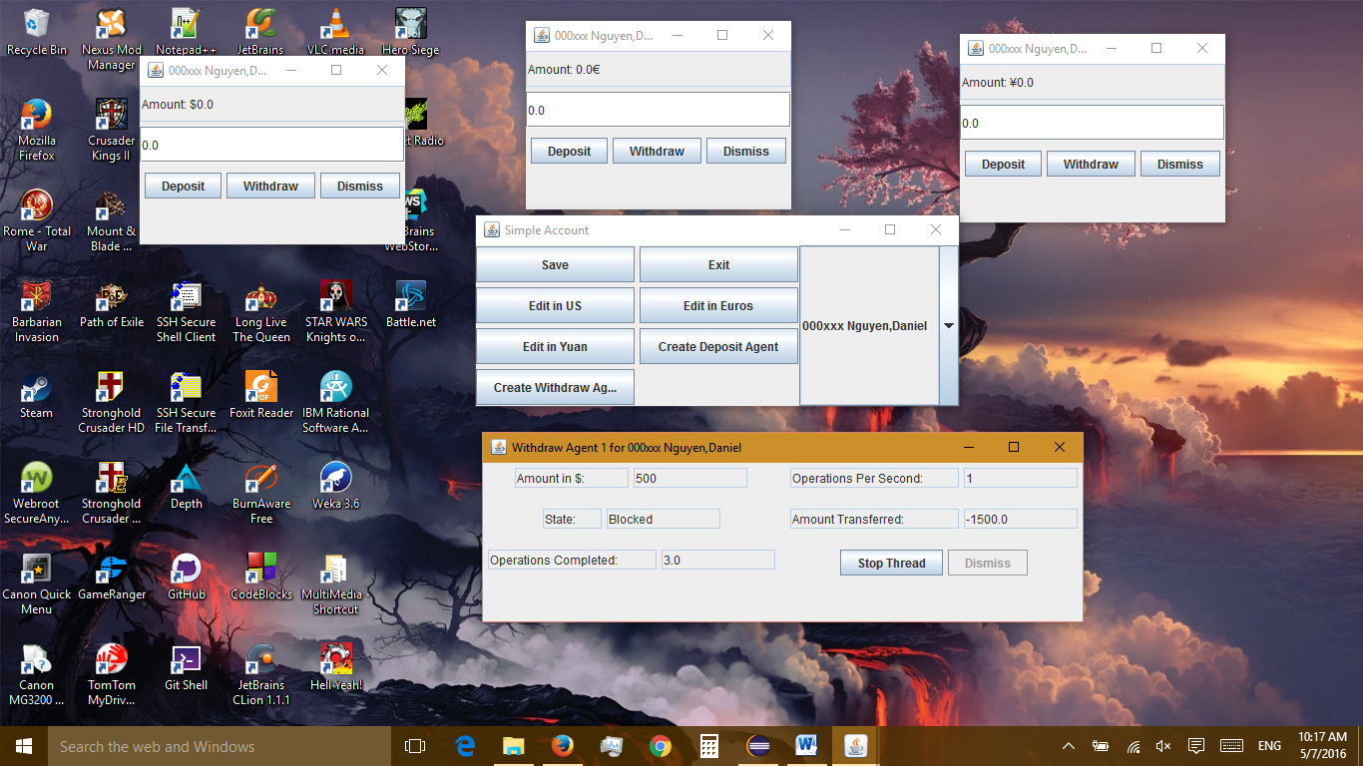

Figure : Reaching blocked status

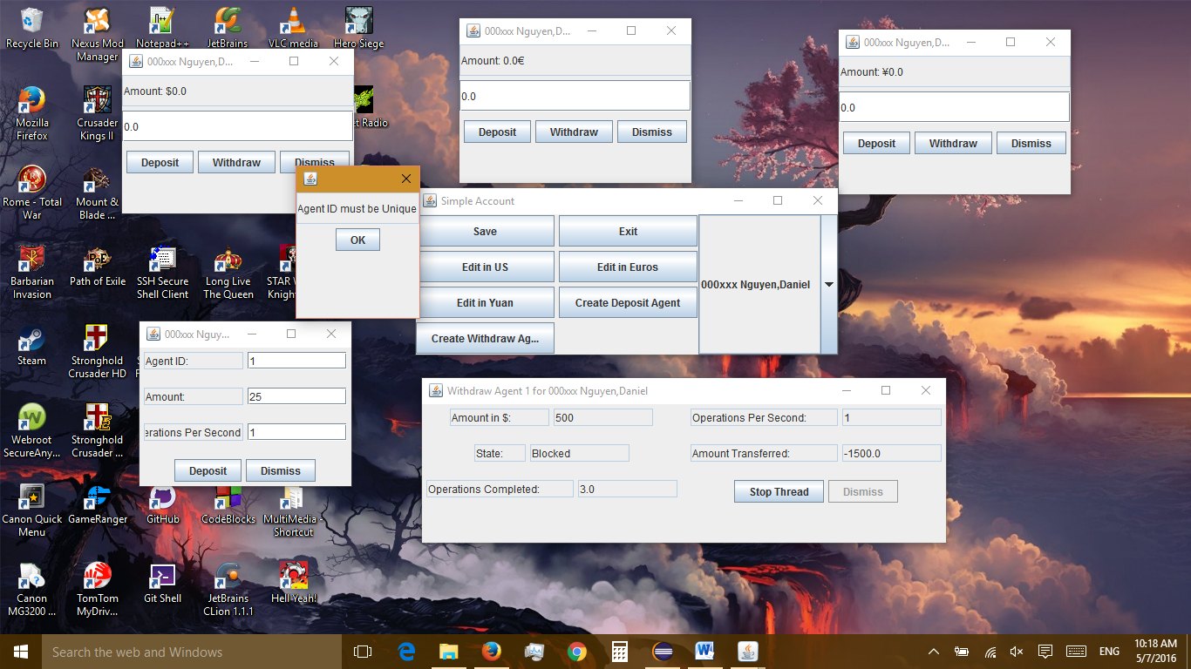

Figure : Threads must have unique IDs

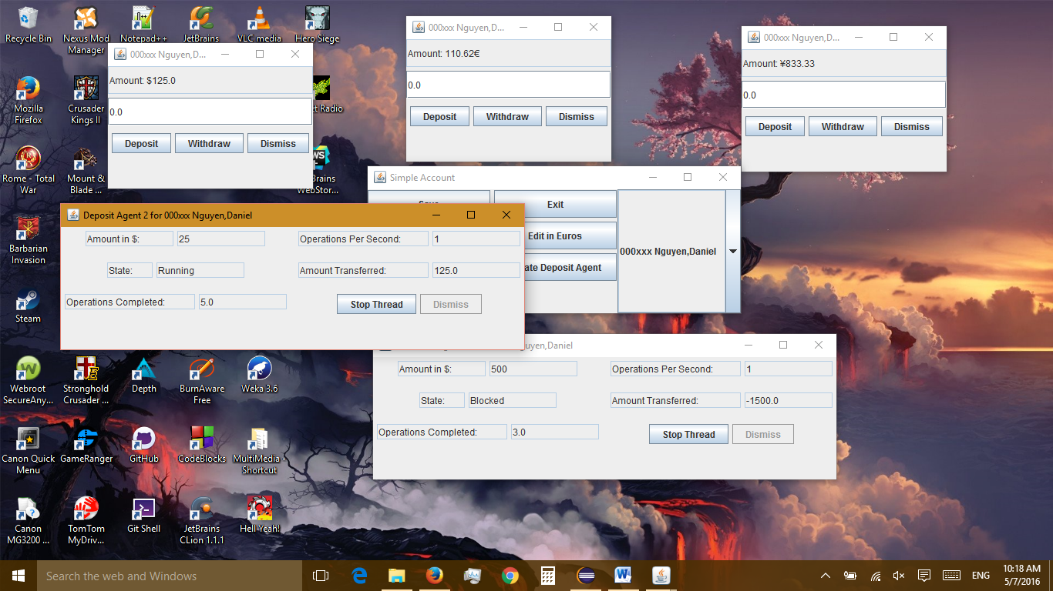

Figure : Deposit Window Running, withdraw unblocks itself (not seen here)

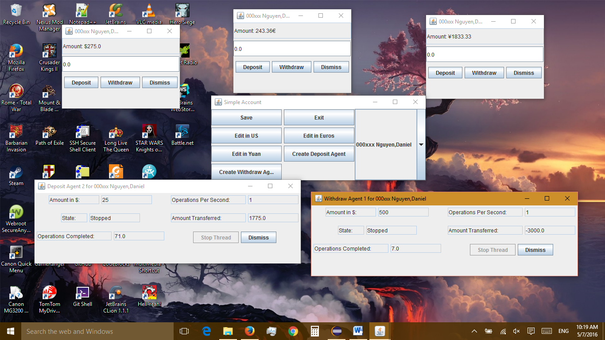

Figure : Both Threads stopped

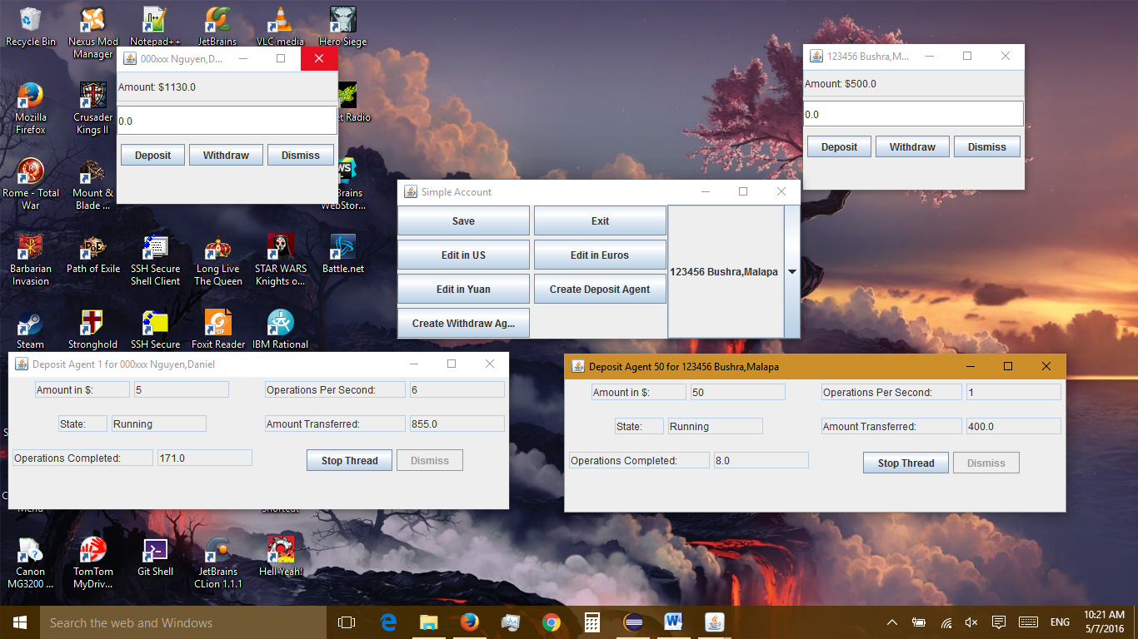

Figure : Threads from separate accounts running at same time

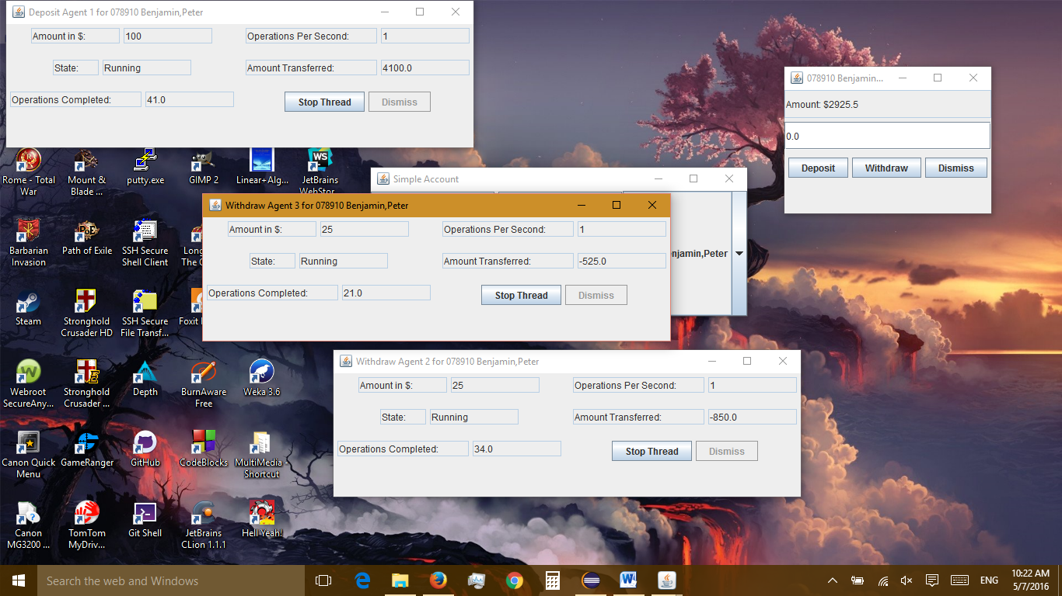

Figure : Multiple threads on same account running